Create a SQL database

Lab Details

1. This lab walks we will walk through the steps to deploy SQL server and create SQL database containing sample data.
2. Duration: **60 minutes**

Introduction

What is Azure SQL Database?

* Azure SQL Database is a fully managed platform as a service (PaaS) database engine that handles most of the database management functions such as upgrading, patching, backups, and monitoring without user involvement.
* Azure SQL Database is always running on the latest stable version of the SQL Server database engine and patched OS with 99.99% availability.
* PaaS capabilities that are built into Azure SQL Database enable you to focus on the domain-specific database administration and optimization activities that are critical for your business.
* With Azure SQL Database, you can create a highly available and high-performance data storage layer for the applications and solutions in Azure.
* SQL Database can be the right choice for a variety of modern cloud applications because it enables you to process both relational data and non-relational structures, such as graphs, JSON, spatial, and XML.

Task Details

1. Launching Lab Environment
2. Create a Azure SQL Database
3. Create a server-level IP firewall rule
4. Connect to the database
5. Create tables in the database

Lab Steps

Task 1: Login to Azure Portal

1. If you have logged into any other Azure Account from previous labs or your own account, please logout of it.
2. Click on the  button.
3. Once the lab creation process is completed, you can see your ***username***and ***password***.
4. **Open a browser tab in incognito mode**. Go to the Azure portal by clicking on the  button or by using URL [https://portal.azure.com](https://portal.azure.com/) in incognito mode.
   * **Note**: It is recommended to use incognito mode to avoid Azure portal cache related issues.
5. If it automatically logs into any other azure account, please logout of it and clear cache.
6. Sign in with your given ***username***and ***password***on azure portal.
7. If login is not working. Click and End Lab and start the lab again.

Task 2: Create a Azure SQL Database

1. On the Azure portal menu or from the Home page, select **Create a resource**.  
   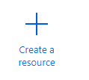
2. On the New page, select **Databases**in the **Azure Marketplace** section, and then click **SQL Database** in the Featured section.

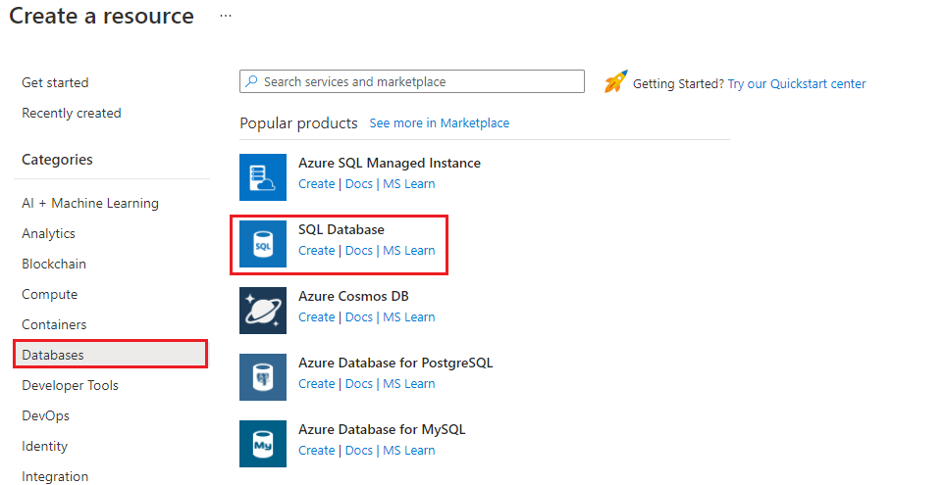

1. Fill out the **SQL Database** form with the following information

* Resource group: Select **resource group_XXXXX**
* Database name: Enter ***WhizDatabase***

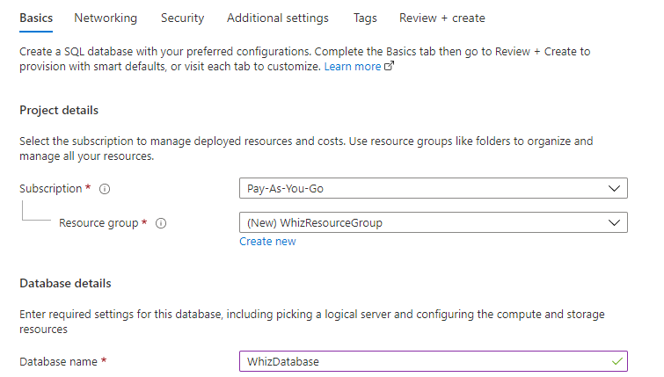

1. Click on **Create new** and fill out the **New server** form with the following information:

* Server name: Enter ***whizlabserver01***  
  **Note**: Server name must be unique
* Server admin login: Enter ***WhizlabAdmin***
* Password: Enter ***Whizlab_123***
* Confirm Password: Enter ***Whizlab_123***
* Location: Select **East US**

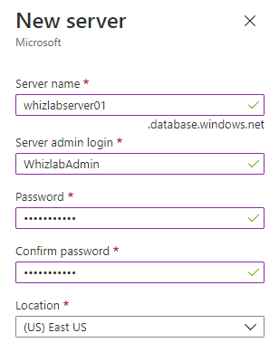

1. Click **Ok**
2. Now that you've completed the SQL Database form, click **Review + Create**and then click on **Create**to provision the database. This step may take a few minutes.
3. On the toolbar, click Notifications to monitor the deployment process.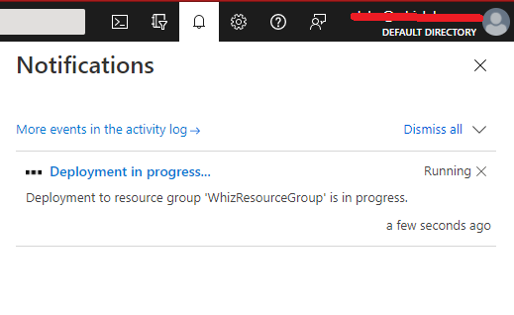

Task 3: Create a server-level IP firewall rule

1. After the deployment completes, select **SQL databases** from the Azure portal menu or search for and select **SQL databases** from the page.
2. Select **WhizDatabase**on the SQL databases page. The overview page for your database opens, showing you the fully qualified **Server name** (such as **whizlabserver01.database.windows.net**) and provides options for further configuration.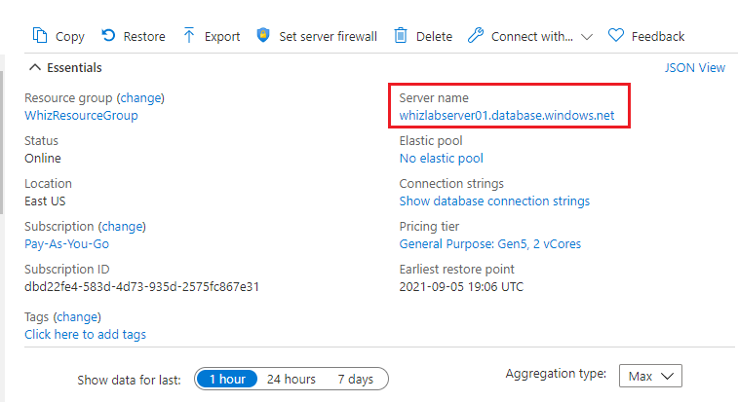
3. Click **Set server firewall** on the toolbar. The Firewall settings page for the server opens.
4. Click **Add client IP** on the toolbar to add your current IP address to a new IP firewall rule. An IP firewall rule can open port 1433 for a single IP address or a range of IP addresses.
5. Click Save. A server-level IP firewall rule is created for your current IP address opening port 1433 on the server.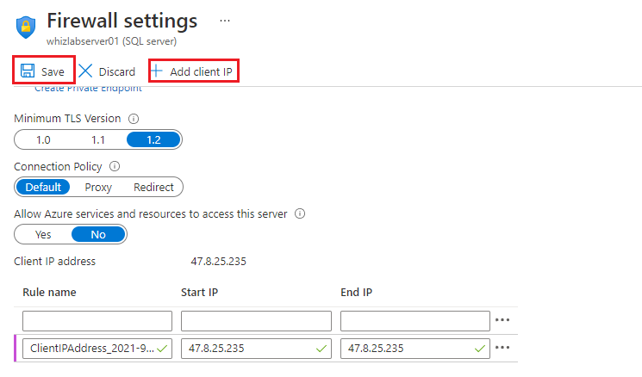
6. Click OK and then close the Firewall settings page.

Task 4: Connect to the database

1. Click on **Query editor** from left hand side menu bar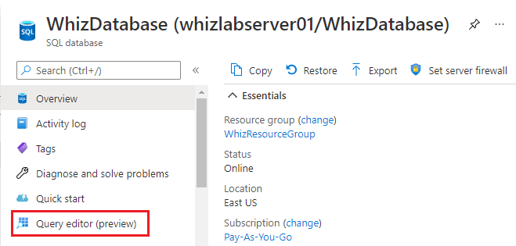
2. Enter ***Whizlab_123***in password box and then click on **ok**  
   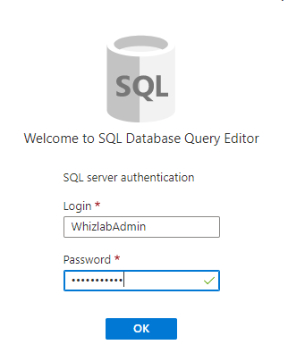

Task 5: Create tables in the database

1. In the query window, paste the following query to create four tables in your database and then click on **run.**You will get the **Query succeeded** message.

|  |
| --- |
| **-- Create Person table**  **CREATE TABLE Person**  **(**  **PersonId INT IDENTITY PRIMARY KEY,**  **FirstName NVARCHAR(128) NOT NULL,**  **MiddelInitial NVARCHAR(10),**  **LastName NVARCHAR(128) NOT NULL,**  **DateOfBirth DATE NOT NULL**  **)**    **-- Create Student table**  **CREATE TABLE Student**  **(**  **StudentId INT IDENTITY PRIMARY KEY,**  **PersonId INT REFERENCES Person (PersonId),**  **Email NVARCHAR(256)**  **)**    **-- Create Course table**  **CREATE TABLE Course**  **(**  **CourseId INT IDENTITY PRIMARY KEY,**  **Name NVARCHAR(50) NOT NULL,**  **Teacher NVARCHAR(256) NOT NULL**  **)**    **-- Create Credit table**  **CREATE TABLE Credit**  **(**  **StudentId INT REFERENCES Student (StudentId),**  **CourseId INT REFERENCES Course (CourseId),**  **Grade DECIMAL(5,2) CHECK (Grade <= 100.00),**  **Attempt TINYINT,**  **CONSTRAINT [UQ_studentgrades] UNIQUE CLUSTERED**  **(**  **StudentId, CourseId, Grade, Attempt**  **)**  **)** |

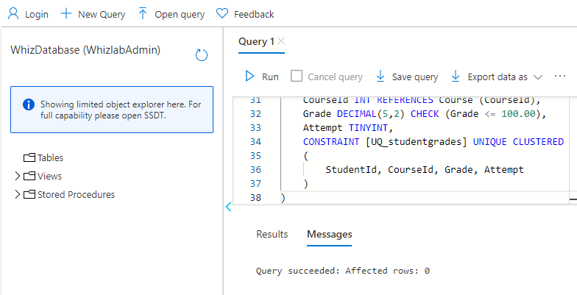

1. Click on the **Tables**tab to view the all the four table that you created.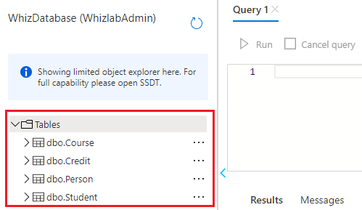

Completion and Conclusions

1. You have successfully logged into **Azure Portal**.
2. You have successfully created an Azure SQL Database.
3. You have successfully created a server-level IP firewall rule.
4. You have successfully connected to the database.
5. You have successfully created four database tables.

End Lab

1. You have successfully completed this lab.
2. Click on **Logout** in Azure Portal by clicking on the logout button in the top right corner inside Azure Profile.
3. Click on  once you have completed the Lab.